Professional Development #2: Modeling Challenge Based Learning

Speaker: Jacob Ohnmeis, Cincinnati Engineering Enhanced Mathematics and Science Program (CEEMS) Exemplar Teacher
Date: June 12, 2018
Time: 2:45-5:00
Venue: University of Cincinnati, Swift Hall, room 608

Prepared by:
Kelly Hiersche, Middlesboro High School, Middlesboro, KY
RET Participant for Project #5: Cybersecurity

This session was presented by Mr. Jake Ohnmeis, a former
CEEMS teacher who is currently teaching math at Goshen Middle School Before starting the session, Mr. Ohnmeis offered the left side of the room a choice of candy or mints but gave the right side of the room a mint. He then directed the group to a website, Todays Meet (see Figure 1), where each person could post how they felt about being given the option to choose versus having no choice. The purpose of this experiment was to create dialogue about the importance of choice. Students need choice so that they experience a sense of control, purpose, and competence.

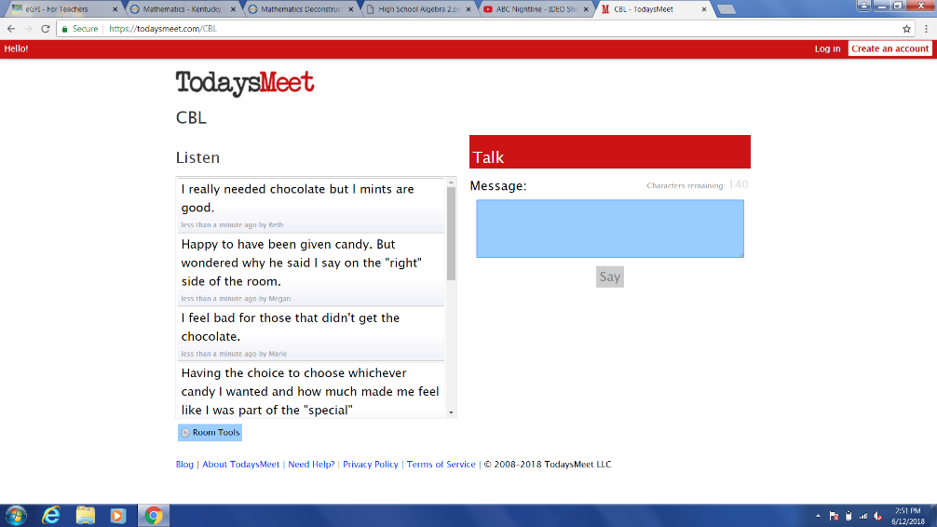
Figure 1: Group Discussing by Mr. Ohnmeis: Candy Experiment to Start Session

Mr. Ohnmeis began his presentation by introducing himself to the group. He teaches students with a wide range of ability from Integrated Math 1 to advanced level math classes for high performing students. His classes are often collaborativebut include a high number of students with learning disabilities and students who are not on grade level. Mr. Ohnmeis encouraged the group to ask questions at any point throughout his PowerPoint, to ensure each person got the information they needed and had a complete understanding of how to implement Challenge Based Learning.

The first topic of discussion was Challenge Based Learning (CBL). Mr. Ohnmeis defined CBL, explained the benefits, and the steps for incorporating CBL into a classroom. Each participant was given a printed version of the Slideshow presentation, enitled “I Challenge You - To Engineer a Design!” Mr. Ohnmeis defined CBL as a pedagogic approach developed by Apple Inc. in which teachers and students take on compelling problems together, looking for multiple solutions to real world problems. Both the process and solutions must be documented and communicated, and technology is often incorporated to solve these problems or challenges. Mr. Ohnmeis continued by pointing out the benefits of CBL, which include the following: it is student centered, promotes engagement, enables acquisition of 21st Century Skills, and increases interest in math and science related careers. Finally, he broke CBL up into seven steps: the hook, the big idea, the essential question, the challenge, societal impacts, guiding questions, and instructional activities. To further enlighten the RET participants to these steps, Mr. Ohnmeis next presented a CBL unit he taught.

The next section of the PowerPoint was titled “Stand Strong with Pythagoras! Using Pythagorean Theorem to Build Structures.” This is a unit used in the Geometry section of Mr. Ohnmeis’s8th grade math class. Presenting this unit gave the Research Experience for Teachers (RET) participants an opportunity to see what a CBL unit looks like ask questions and participate in discussion. Mr. Ohnmeis walked the RET participants through the main planning steps of his unit, which included the generation of essential questions; selection of one essential question; defining a challenge; the guiding of students that need to be answered to find an optimal solution for the challenge, and, the implementation of curricular activities. Ensuring all these steps are executed creates an optimal opportunity to engage students in a hands-on, exciting, real-world activities while searching for a solution to the challenge.

After presenting the unit, Mr. Ohnmeis highlighted the Engineering Design Process (EDP) as a process that should be used as students seek an optimal solution for the challenge. This section gave information about the steps of EDP and contained suggestions on grouping students into teams. He ended the presentation section of the session by showing the RET participants pictures and videos of the solutions his students had created for his Pythagorean Theorem unit challenge.

The final section of this session allowed the RET participants to play the role of Mr. Ohnmeis’s 8th grade math students, , as they participated in the “hook” for the unit he had presented. Teachers were given twenty minutes to build a structure at least eleven inches tall, that could hold as many textbooks as possible, using three 8.5” x 11” sheets of paper, 1 color poster board, 1 roll of scotch tape, 1 coffee stirrer, and 4 sticks of bubble gum. The ten RET participants were broken up into two teams of five, to begin building (see Figure 2). Once both teams had created their structures, the structures were tested in the front of the room by placing textbooks on top of the structures (see Figure 3). Both structures were able to hold the weight of nine textbooks. Once teachers completed the “hook” there was time for questions.

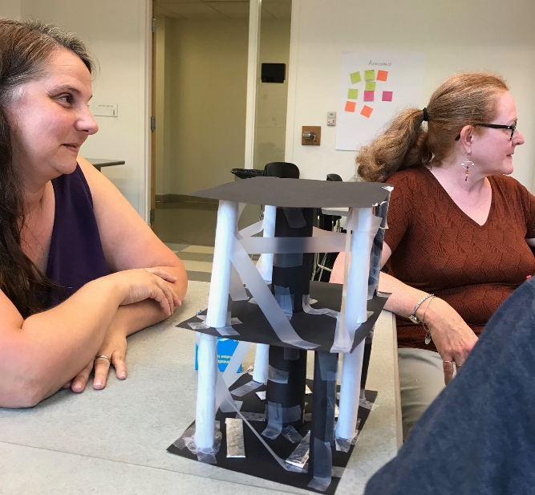  Figure 2: One Team Building their Structure | 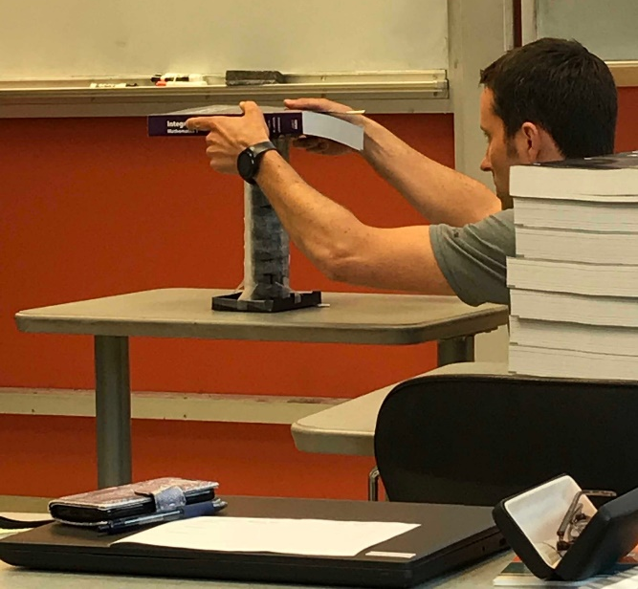  Figure 3: The second Team Testing their Structure

